Breast Augmentation Primer

Breast augmentation is the most frequent operation Dr. Song performs. To achieve beautiful results, and the highest level of patient satisfaction, there are several decisions that need your consideration. Dr. Song has assembled this primer to aid you in thoughtfully navigating the decision-making process.

Please review the following information and consider what is best for you, and is most in line with your aesthetic goals. During your consultation, Dr. Song will review the following material, and answer any questions you may have. The following information reflects Dr. Song’s opinions, but is supported by medical literature and personal experience.

When planning breast augmentation, both you and Dr. Song will work together to develop a plan based on these decisions:

- Type of implant
- Incision location
- Implant location
- Is a lift required?

Implants

There are literally thousands of breast implants. They come in a large variety of shapes, sizes, textures, profiles, and fill materials. The following is an explanation of the various choices to help you make an educated decision.

Fill Material – Saline vs Silicone Gel
All breast implants are manufactured with an outer silicone shell. The difference between a saline and silicone gel implant is what is inside the implant. Saline is the same as “salt water”, and is the same solution that makes up 70% of the weight of our bodies. Silicone is a semi-solid gel filler that is almost completely inert and non-reactive with our body tissue. Silicone gel implants were FDA-approved for use in breast augmentation in 2006 after many carefully designed studies followed thousands of women and confirmed their safety.

Some of the points to consider when deciding between silicone gel and saline:

- Both do an excellent job of augmenting your breasts, and both come in a wide variety of sizes, shapes, and textures.
- Both are safe, and silicone gel has NOT been shown to be associated with any auto-immune disease or breast disease.

- Neither needs to be changed at an arbitrary time period, as is a common myth that implants need to be replaced every 10 years.
- Silicone gel implants are only available to women aged 22 years and older.
- Cost – silicone gel implants are on average $1000 more than saline implants
- Feel and appearance – for that extra $1000, silicone gel implants feel and look more natural. They are softer, and more closely mimic your own breast tissue. This is more important is you are starting off with a smaller amount of breast tissue, or you are looking for a larger sized implant.
- Rupture detection – Although the risk is low, implants may leak or rupture at some point during their lifetime. If a saline implant ruptures, your body will absorb the fluid and you will notice an immediate difference between the two breasts. However, if a silicone gel implant fails, it is not quite as easy to determine whether or not the implant has ruptured. The silicone gel is created in a high-cohesive form, which means that the gel has resistance to flow, and will remain a “blob” even when outside the shell. What does this mean? If a saline implant ruptures, you can call your surgeon, and have the implant replaced. If the silicone gel implant fails, you will only know if you do the appropriate screening. Although the silicone gel will not harm you by being in contact with your tissues, it will likely cause capsular contracture (hardening of the scar around the implant) over time. This being said, it is easy to routinely screen your silicone gel implant. Officially, the FDA recommends that an MRI be completed 3 years after your augmentation, and every 2 years thereafter. However, a standard mammogram can screen your implant almost as effectively as an MRI. Most women 40 and older, use their yearly insurance-covered mammograms to screen both the breast for disease, as well as the implant for rupture. For women younger than 40, Dr. Song will talk to you about your options.
- Breast cancer screening – Women still need to screen their breasts for disease, and unless you have a personal or family history of breast disease, you should start having yearly mammograms at age 40. Implants actually make it easier for the radiologist to evaluate the breast tissue. It is not dangerous to have a mammogram with an implant in place.
- Health insurance – Although rare, some insurance companies define breast implants as a “pre-existing condition”, and thus breast augmentation may affect your eligibility or coverage. Please speak to your insurance company before you proceed with surgery to determine if this will affect your policy.

Round vs Anatomic
Implants come in two primary shapes – round and anatomic (teardrop shaped). Anatomic implants are selected when patients have no breast tissue, such as breast reconstruction, and have a slightly higher risk of leak and asymmetry of the breast. In 99.9% of procedures, Dr. Song uses round implants because of their known efficacy, and safety profile.

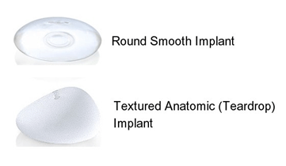
Smooth vs Textured
Implants can be created with smooth or textured outer silicone shells. There have been many clinical studies examining the benefits and risks of both types, and there has been just as much conflicting data. In Dr. Song’s experience and professional opinion, most women do best with smooth implants, and this is his current preference. Smooth implants move around in their capsules – a characteristic useful for creating more symmetric and natural-appearing breasts. Dr. Song uses textured implants if an anatomic implant is selected, or if a patient has had recurrent capsular contracture, and is undergoing revisionary surgery.

Profile: Moderate, Moderate Plus, High
Round implants are created in three profiles, or heights. Choosing a profile is mostly Dr. Song’s decision in order to fit the volume desired by the patient to their specific breast shape. For example, if a patient has an internal breast (base) diameter of 12cm, then the implant should be roughly 12cm to create the best aesthetic result. An implant that is 10cm or 14cm would look strange. If the patient desired a 250cc implant, then a moderate profile implant would most closely match her base diameter of 12cm. On the other hand, if she opted for a 500cc implant, only a high profile implant would allow that extra volume to be managed without expanding the base diameter.

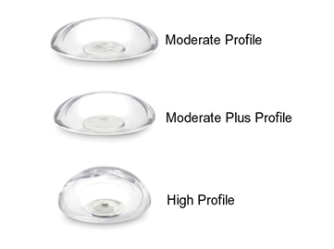

Incisions

There are four possible choices for incision location – around the nipple (periareolar), in the bottom breast crease (inframammary), through the armpit (trans-axillary), and through the belly button (trans-umbilical – Dr. Song does not perform this technique). There is no difference in risk, outcome, or sensitivity changes between the periareolar and inframammary approach. There is a slightly higher risk of asymmetry with an armpit incision, and if revision is necessary after this approach, a new incision on the breast (i.e. periareolar or inframammary) must be selected. It is entirely your decision which incision is used for placement of the breast implant, and depending on your anatomy and breast shape, Dr. Song will make recommendations to give you the best outcome.
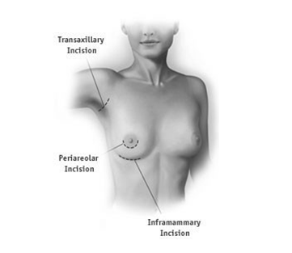

Above Or Below The Muscle?

Breast implants can be placed above, below, or partially below the pectoralis major muscle. Most implants are placed below the muscle, especially saline implants, as the muscle provides another level of tissue to camouflage the implant. Additionally, mammograms can more effectively image the breast tissue with the implant located below the muscle. Another benefit is that the risk of capsular contracture is slightly lower with placement below the muscle. The downside is that with activation of the pectoral muscle, the implant will animate. This is usually only an issue for body builders and weight lifters. Placement above the muscle (subglandular), or in a partially submuscular position (dual-plane), is useful in patients with sagging of the breasts or a history of significant weight loss. Dr. Song will discuss the best plane of placement for you depending on your breast anatomy.

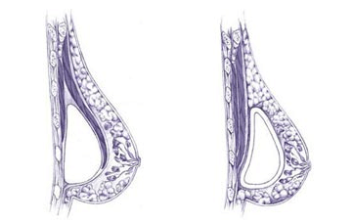

Do You Need A Breast Lift?

Breast augmentation adds volume to the breast, and only slightly will rotate up the position of the nipple. It is not a procedure that will correct sagging or drooping of the breasts. If you can rest a pencil underneath your breast, and it does not fall, then you likely need a breast lift. This can be done in combination with the augmentation. If you require a lift, and choose just to have an augmentation, then you will likely end up only with larger, sagging breasts. There are several techniques for the breast lift procedure including the “donut”, “lollipop”, and “anchor” scar breast lifts. Dr. Song will discuss what is the best surgery to deliver the breast enhancement you desire.

General Information

Breast augmentation is an outpatient operation, and is usually done under general anesthesia. All surgeries are done at an accredited outpatient surgery center with board-certified anesthesiologists. The outpatient surgery center of choice for Dr. Song is the Irvine Multi-Specialty Surgery Center on Barranca Parkway.

Most patients resume normal daily activities within 2 days, and can return to work after 1 week. You are able to return to the gym for light exercise at 3 weeks, and can resume full activities after 6 weeks. You will be taught stretching exercises that should begin immediately after surgery, and will greatly reduce your recovery period.

In the days following surgery, your implants will appear high and feel firm. By 4 weeks after surgery, the swelling has decreased and the breasts will start to look great! By 4 months, all the residual swelling has resolved, and the tissue has stretched to its final position. Post-operative visits are usually on post-op day 1, week 1, month 1, and month 6.

Risks Of Breast Augmentation Surgery

Every surgical procedure inherently carries risk, as does general anesthesia. Complications common to any procedure include: bleeding, infection, medication or anesthesia reaction – though these risks are extremely low (< 1%). With proper selection of patients and the surgery indicated, the complication rate is extremely low.

Complications specific to breast implant surgery include:

- Implant failure – Breast implants can leak or rupture at some point during your lifetime. They should not be expected to last forever, and will likely have to be replaced at some point. The risk is approximately 10% at 10 years, and with proper implant screening, they can be replaced without problem.
- Capsular contracture – The body’s normal response to a breast implant is to form a thin, soft, and compliant capsule (scar) around the device. This becomes pathologic when the capsule tightens and constricts the implant causing it to feel firm and potentially deform the breast. This occurrence is low, approximately 5%, and is not readily predictable. Treatment for capsular contracture is implant and capsule removal, and replacement of permanent implant.
- Wrinkling and rippling – Visible and palpable wrinkling of implants can occur. It is more frequently seen in thin patients with large, saline implants and with placement in the subglandular plane, but can occur in any scenario. This is best prevented by smart planning, but if it occurs, there are techniques to minimize the problem.
- Changes in sensation – Some change in nipple sensation, whether more or less sensitive, is normal in the immediate post-op period. In the vast majority of patients, the sensitivity return to normal within a couple months. It is only a very small possibility that there will be any permanent change or loss of sensation. This is not associated with use of one incision versus another, it is more closely linked to size of implant. The larger the size of the implant, the greater the risk of sensory disturbance.
- Implant displacement – Displacement of the implant may occur from its initial placement, and can be accompanied by discomfort and/or distortion and poor appearance of the breast shape. Additional surgery may be necessary to correct this problem.

Additional Breast Implant Advisory Information

- Breast cancer – Current medical literature does not demonstrate any increased risk of breast cancer in women with breast implants for cosmetic or reconstructive purposes. It is still recommended that you perform periodic self-breast examination, have mammography surveillance according to the American Cancer Society guidelines, and seek professional care should you notice a breast lump. Care must be exercised when performing breast biopsy in an augmented breast.
- Mammography – Breast implants may interfere with full visualization of all breast tissue utilizing standard mammography. This is more true for implants placed in the subglandular position. For women with breast implants, the radiologist will take extra radiographs called “Eklund views” to visualize breast tissue around the implant.
- Long term results – Subsequent changes in breast shape will still occur as a result of weight loss or gain, pregnancy, and the natural course of aging.

How Do I Choose My Size?

During our consultation, I’ll talk to you about your medical and breast health history, and what you desire from breast enhancement. During the physical examination, I will make several measurements, and examine your chest and breast for size, shape, symmetry, droop, and any irregularities. Based on these findings, we will discuss your options for incision, implant size, type, shape, and location.

Because cup size is highly variable and an imprecise method to gauge volume needed for augmentation, you will try on a variety of “sizers” with a non-padded bra. Once you select a volume that you are comfortable with, I’ll add approximately 10% more to that volume (to account for the implant being on top of the breast during the sizing process), and will match that to your base width to select the appropriate implant that will achieve your desired result.

Breast Surgery Questionnaire

Name Age Date

Height Weight Current bra size

Do you have any of the following?
Yes No
- Nipple discharge
- Breast masses
- Fibrocystic breasts
- Breast pain
- Skin changes over your breast
- Difficulty examining your breast
- Change in breast size with
menstrual cycle

Do you practice self-breast examination?

Have you had a mammogram?
If Yes, what was the date?
If Yes, what was the result?

Have you had any previous breast surgery?
If Yes, what was the date?
If Yes, what was the result?

Any family history of breast cancer?
If Yes, what age and relation to you?

How many children do you have? Did you breast feed?

What is your desired bra size after augmentation?

Determining Bra Size

There are two components to bra size: Band Size (e.g. 34 or 36) and Cup Size (e.g. B or C). These are not independent measurements, as the cup size will vary depending on the band size. For example, a “C” cup is not the same between a 34 bra and a 36 bra. The 36-C will be a significantly larger breast than the 34-C.

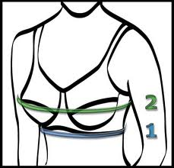

- Band Size (#1) – Measure around your torso, directly under your bust. Be sure the tape is straight across your back and pull it snugly around you. Round off the measurement to the closest whole inch, either up or down. If the rounded measurement is an even number, add 4 inches; if it is an odd number, add 5 inches.

- Cup Size (#2) – Standing with your arms at your sides, measure around the fullest part of your bust. Round this number – up or down – to the nearest inch. Subtract your band size measurement from this second, larger measurement. The difference is your cup size, as listed in the following chart.

0” -1/2” | 2” | 3” | 4” | 5” | 6” | 7”
A | B | C | D | DD / E | DDD / F | G

